Department of Education: Master’s Thesis Template

First Name Family Name

Master’s Thesis in Education

Spring Term 2014

Department of Education

University of Jyväskylä

ABSTRACT

Jones, Mary. 2014. Template for Master’s Thesis in Education. Master's Thesis in Education. University of Jyväskylä. Department of Education.

The Abstract is an independent section that can be understood without reading the original publication. The bibliographic data are provided in the Abstract in the same form as they appear on the title page.

The first paragraph presents the studied phenomenon and the purpose of the study. The maximum length of the Abstract is 250 words. It is written on one page, using line spacing 1.5. Paragraphing is recommended if the Abstract is longer than 50 words.

The implementation and methods of the study are described in the next paragraph. The Abstract contains no tables or graphics. The Abstract page is placed immediately after the title page.

The third paragraph presents the main results. The Abstract should specify the purpose and subject of the study (what has been studied and why), the research methods (how), and the main research results and conclusions (the central contribution of the study). You should eliminate unnecessary words but still use complete sentences.

The fourth paragraph presents the conclusions. The Abstract ends with keywords: 1–7 words that describe the content of the work. Choose the first keywords from your thesis title. In choosing the rest, you can use the keyword lists of, for example, Psychological Abstracts, EUDISED or ERIC.

Keywords: word 1, word 2, word 3, word 4 (maximum 7)

CONTENTS

1 INTRODUCTION 5

2 CONTENT-RELATED HEADING 8

2.1 Always at Least Two Same-Level Subheadings 8

2.2 Always at Least Two Same-Level Subheadings 9

2.2.1 Third-Level Heading 9

2.2.2 Third-Level Heading 9

2.2.3 Always at Least Two of These, Too 9

3 CONTENT-RELATED HEADING 11

3.1 Always at Least Two Same-Level Subheadings 11

3.2 Always at Least Two Same-Level Subheadings 13

4 RESEARCH PROBLEMS / RESEARCH TASK 14

5 IMPLEMENTATION OF THE STUDY 15

5.1 The Research Topic/Subject and Approach / The Context of the Study (*not obligatory*) 15

5.2 The Subjects/Participants / The Participants and the Research Process 15

5.3 Research Methods 15

5.4 Data Analysis (in a qualitative thesis already here) 15

5.5 Reliability 15

5.6 Ethical Solutions (*qualitative*) / Data Analysis (*quantitative*) 15

6 RESULTS 16

6.1 Answering Research Problem 1 (heading according to content) 16

6.2 Answering Research Problem 2 (heading according to content) 17

7 DISCUSSION 18

REFERENCES 19

Appendices 21

# INTRODUCTION

These are general guidelines. They have been primarily created in compliance with the practices of quantitative research, so please note that the structure of a qualitative research report can be different. The structure of a thesis can also be similar to an extended research article, where the presentation is more compact and the structure more simplified. In theses written in English (or other languages), you should follow APA referencing style (Publication Manual of the American Psychological Association). However, you can choose whether to use British or American English.

The purpose of the Introduction is to sell the topic to the reader. You should start by presenting the general context of the study, that is, the phenomenon. Make observations that highlight the importance and topicality of your research topic. Thereafter, explain in more detail the perspective from which you approach the phenomenon. Finally, define the aims of your study more closely. You can also briefly outline the structure of the report. You should use references in the Introduction as well. Here you should only present the most central focuses of your research – everything is not presented or studied as part of the theoretical background. As a researcher, you should understand the big picture of the analysed phenomenon as well as the relationship of your study to the theme as a whole (which requires that you are well-read in the topic).

The correct use of references is one of the most important indicators of high-quality academic writing.

According to good referencing practices, you should identify – in a clear and individualised manner – the source from which you have taken each observation or interpretation. Hirsjärvi, Remes, and Sajavaara (2007, p. 322) note as follows:

It is rather common that inexperienced authors place the reference, possibly even a bunch of authors’ names, at the end of a paragraph, without specifying which part of the paragraph is based on which source, or what the author’s own contribution is. This inexact procedure does not meet the requirements of accurate and reliable referencing.

In addition, Hirsjärvi et al. (2007, p. 327) give a clear rule to follow:

With no preceding mentions of the author, a reference is precise only after two sentences. A reference should thus not be used alone at the end of a paragraph, for instance.

A disconnected reference should thus not be placed at the end of a paragraph. The most unambiguous and recommended practice is mentioning the source in the first sentence in which the content is used. Potential further references are expressed so that the reader is able to judge whether the same source is still being used.

You do not necessarily need to use references in, for instance, general bridging sentences (often at the beginning of paragraphs) after which you proceed to more detailed illustrative data that support a hypothesis. Neither do you need to indicate the source for general assumptions, statements or speculative sentences that are specified immediately thereafter (e.g. ‘Parents may have some beliefs and explanations related to their child’s success before the child starts school.’). Naturally, no references are needed in sentences in which you personally evaluate or summarise studies, or in sentences in which you evaluate your own research and results*.*

When you refer for the first time to a source that has *from three to five authors*, list the names of all the authors (Kernis, Cornell, Sun, Berry, & Harlow, 1993). If you write your thesis in English, use the abbreviation *et al*. (Kernis et al., 1993) in any later references. If the source has *six or more authors*, use the abbreviation starting from the first time you refer to the source. If the source has *two authors*, both are always mentioned. Authors are linked with ‘and’ in text. If the authors and the year are within brackets, use an ampersand (&).

All the references used in the text must be found in the list of references (References), and each source mentioned in the list of references must appear in the in-text references at least once. If the source is a book, the References provide the author’s family name and the initials of given names, the year of publication (in brackets), the title of the book, the place of publication /publisher’s city (i.e. not where the printing house is located), and the name of the publisher. The publisher’s name is given in the shortest possible way (e.g. instead of the long form *McGraw Hill Company, Inc.* write *McGraw Hill*). The page numbers of articles in journals, edited works or compilations are given in the References.

List your sources in the References according to the following guidelines:

1. References are listed in *alphabetical order* according to family name.
2. Several works by the same author are listed according to their year of publication: the earliest work comes first.
3. If an author has co-authored publications in which he/she is mentioned as the first author, these publications are listed in the References in their own chronological order after the publications written alone.
4. Works published by the same author in the same year are alphabetised according to their title and distinguished by lower-case letters (e.g. 1990a and 1990b). This is the procedure only if there is no co-author whose family name can be used to identify the source unambiguously.

Replace the examples listed under *References* with your own source publications. Remember not to include our examples in the final version of your References.

Include page numbers in in-text citations always when you (1) use direct quotations, (2) refer to a research group’s tables, figures or models, or (3) refer to a research group’s individual research findings, interpretation of results or theoretical hypotheses. Page numbers need not be used in other cases. If you want to give page numbers also in cases in your master’s thesis, they need to be given consistently in the entire thesis.

# CONTENT-RELATED HEADING

## Always at Least Two Same-Level Subheadings

All text elements are formatted using Word styles. Begin a new text paragraph using the Body Text (1. Tekstikappale) style. In the following text paragraphs, use Body Text First Indent (Leipäteksti). Remember that the first paragraph is not indented. Neither should you indent a paragraph that begins after a quotation, table or figure: in these you should also apply the (1. Tekstikappale) style.

In headings, use the style that corresponds to the level of the heading. Fourth-level headings are not used at all, and the text should be structured so that it is not needed.

Styles are applied by clicking first on the text and thereafter the suitable style in the menu bar (Figure 1). You can also highlight the text you want to modify, which enables you to modify several text paragraphs at the same time. You can make all styles appear on your screen by clicking the arrow at the bottom right edge of the style menu (Figure 1).



FIGURE 1. The styles visible in the top bar of Word

The page count begins on the title page and continues uninterrupted until the last text page (including the References and Appendices). However, page numbers should be visible only starting from the first page after the first main heading in the body text. Page numbers (with no full stops) are marked at the top right corner of each page.

## Always at Least Two Same-Level Subheadings

### Third-Level Heading

No fourth-level headings (e.g. 2.2.2.1) are used. If it is necessary in order to structure the text logically, you can use headings at the beginning of lines.

### Third-Level Heading

Note that at least two third-level headings are required!

### Always at Least Two of These, Too

Tables and figures are numbered separately, each with consecutive Arabic numerals (1, 2, 3, etc.). The reader should be able to understand tables and figures with their captions without reading the actual text. Line spacing can be smaller in captions than in the actual text.

The title of a figure is placed below the figure, whereas the title of a table is placed above the table. Table columns are not separated by vertical lines. Particularly in statistical tables, horizontal lines are used only to separate the title bar from the rest of the table, and at the end of the table (see Table 1).

TABLE 1 The Relationship Between Self-Efficacy and Teacher’s Background (Kumpulainen, 2012)

|  |  |  |  |
| --- | --- | --- | --- |
| Sum mean values of self-efficacy | Teacher’s personal background factors | | |
| Year of birth | Teaching experience1 | Work experience in present school1 |
| Participation of pupils | -.11 | .12 | .12 |
| Counselling strategies | -.00 | -.02 | .05 |
| Organising group activities | -.24* | .33** | .35** |

*p ≤ .05, **p < .01; 11 = less than a year, 5 = more than 15 years

The words TABLE and FIGURE are usually written in capital letters when they appear in connection with the title of the table or figure. The paragraph immediately after a table or figure is not indented. The aim is to write full pages. When referring to figures and tables in text, use numbered references, for example: (Table 1) or (Figure 1), and not, for instance, “the figure below”. Furthermore, you must refer to each table at least once in the text.

Do not end a section with a table, figure or quoted material. The end should consist of summarising or explaining text, or otherwise the graphics or quotes should be placed earlier in the text.

# CONTENT-RELATED HEADING

## Always at Least Two Same-Level Subheadings

The assessment criteria for master’s theses are presented below (see Table 2). The criteria serve simultaneously as a model for creating a long table. If the table continues on several pages, you should add an extra line for the table title at the beginning of the table. Thereafter, you can activate the table property ‘Repeat as header row at the top of each page’. Table tools appear when you select the table. You can see the table settings in the Design and Layout tabs of the tool bar. Then you can also choose which header rows are repeated automatically. .

| TABLE 2 Master’s Thesis Evaluation Criteria | |
| --- | --- |
| Grade | Verbal description |
| Sufficient (1) | The study meets the minimum requirements for master’s theses in education. The background of the study is either too narrow or too broad. The purpose of the study is discussed to some extent in the Introduction. However, connections to background theories and earlier research as well as to pedagogical and educational practices are not explained. The summarised theories and studies are loosely related to the research problems. The use of research methods is inadequate or inconsistent. The presentation of results is superficial or list-like, and there are shortcomings and inconsistencies in the results or conclusions. Discussion is scarce and does not reach a more general level of interpretation. The language is fairly poor and unfinished. |
| Satisfactory (2) | The topic is ordinary, or its justifications or focusing are insufficient. Relevant theories and research results have been presented in a list-like and mechanical manner, or the presented background as a whole is too broad or too narrow. The author has tried to relate the starting points of the study, as well as the research tasks and problems, to earlier knowledge, but has not succeeded. Some of the research tasks are only loosely connected to the background or are not considered in connection with the results. The research methods have shortcomings in, for example, methodological handling. The results are presented formulaically. The connection to the background remains modest. The interpretation of results demonstrates a connection to the starting points of the study and to earlier results. |
| Good (3) | The significance of the thesis topic has been stated and demonstrated. The theoretical background of the study has been thoroughly studied, and it shows familiarity with earlier research. The chosen literature is relevant to the research problems, and foreign literature has been used as an essential part of the study. The background theory of the thesis or the practical basis of the phenomenon has been explicated, and the relation of the research task/problems to them has been demonstrated, but it has not been done thoroughly. The choice of research method has been justified in a way which demonstrates knowledge of other methods |
| Very good (4) | The thesis addresses a new, interesting or important theme, whose problems have been outlined and developed independently. The theoretical background and starting points of the study demonstrate good familiarity with the theory. The research tasks/problems have been described precisely, justified in a variety of ways and skilfully related to the theoretical background. Domestic and foreign research literature has been used diversely. Critical, thorough work has been done in selecting the source literature, as well as in reporting and documentation. The choice of research method and its justifications are methodologically knowledgeable. Data collection and analysis methods are used more competently than on average, and their validity for the research task has been evaluated and demonstrated. The chosen analysis method is in harmony with the research task and the data. The interpretation of results and the conclusions are logical, justified and contribute to the research as a whole. As to the language and structure of the thesis, it is a coherent, high-level entity. |
| Excellent (5) | The topic of the thesis is clearly more demanding or significant than on average. The thesis demonstrates the author’s profound familiarity with relevant theory, methodological problems and scholarly practices, in addition to excellent mastery of research work and reporting. Independent and internalised thinking is visible in several subareas of the research process, particularly in the areas emphasised among the evaluation criteria:  a) restructuring and synthesising theory and earlier research in a way that produces new perspectives  b) freshness, significance and innovativeness of the research topic and task  c) focusing of research objectives, starting point and problems  d) choice, development, evaluation and application of data collection and/or analysis methods  e) interpretation of results, conclusions and discussion.  The thesis demonstrates an independent, critical and innovative research approach and the ability to define research tasks and theoretically analyse broad thematic and problem entities. The research method has been developed and evaluated independently. The methodological analyses are independent and of a high level, and the results are scientifically significant. Multifaceted discussion, in which the different issues are skilfully considered, demonstrates an excellent ability to thoroughly acquaint oneself with a theme and to structure, undertake and report on scientific research. The results have scientific value as findings that lead to applications, justify broader research and/or enable theoretical and methodological development. The style of the thesis is excellent, its structure clear and logical. ***As a whole, the grade Excellent (5) requires strong scientific merits.*** |

The advanced studies in the Master of Education degree include a master’s thesis. The purpose of the thesis is to develop students’ ability to independently collect research data, to analyse and critically evaluate existing data, and to independently produce and apply data. The thesis demonstrates that the student masters scientific thinking and can define research problems related to the studied phenomenon as well as analyse and report on the phenomenon. The master’s thesis can be completed either alone or in pair work. The recommended extent varies from 60 to 90 pages, depending on the nature of the thesis.

Master’s theses are graded on a scale of 0–5 (fail, sufficient, satisfactory, good, very good, excellent). In order to determine the overall grade, attention is paid to the following central criteria, each of which is assessed on a scale of 1–5: 1) Theoretical conceptualisation of the studied phenomenon; use of sources (EMPHASIS), 2) Research tasks and problems, 3) Data collection methods and the relevance of data, 4) Analysis of the research data, 5) Presenting the results and answering the research questions (EMPHASIS), 6) Interpretation of the results; discussion (EMPHASIS), 7) Consideration of the reliability and limitations of the study, 8) Research ethics evaluation, and 9) Language and structural coherence. Different orientations of different theses are taken into account in assessment, and the criteria are applied accordingly.

## Always at Least Two Same-Level Subheadings

The head of the department assigns two examiners for the master’s thesis. The examiners write a statement on the thesis and propose a grade. The thesis is evaluated using a form. The head of the department decides on the approval and grade of the thesis based on the examiners’ statement. The thesis is part of your degree and subject to open evaluation. It also becomes immediately public after its approval.

# RESEARCH PROBLEMS / RESEARCH TASK

This part can be a main section of its own, even though in qualitative research you can also include this kind of content in the Introduction. More text ….

More text text. More text… More text.

1. The first research problem.
2. The second research problem.
3. The third research problem, etc.

# IMPLEMENTATION OF THE STUDY

## The Research Topic/Subject and Approach / The Context of the Study (*not obligatory*)

## The Subjects/Participants / The Participants and the Research Process

## Research Methods

## Data Analysis (in a qualitative thesis already here)

## Reliability

In a quantitative study, Reliability and Validity are subsections of this section. They focus on such themes as the repeatability of used indicators, internal logic and links to other indicators that measure the same concept. In a qualitative thesis, you do not automatically need to use such subheadings as reliability – equivalence, transferability, verifiability. The reliability of the study is also reflected upon in the Discussion section. In a quantitative study, the Discussion can address such issues as the study design and how representative the sample is. In a qualitative study, you can reflect on the performed analysis and the participants in the study, just to name a few themes.

## Ethical Solutions (*qualitative*) / Data Analysis (*quantitative*)

# RESULTS

You can begin the Results section by describing briefly how the indicator is constructed or by summarising the results very briefly.

## Answering Research Problem 1 (heading according to content)

The first research question or problem is usually answered in the first subsection of the Results section. Note that the indicators can be constructed in different ways in qualitative research. Text text… (Figure 2).

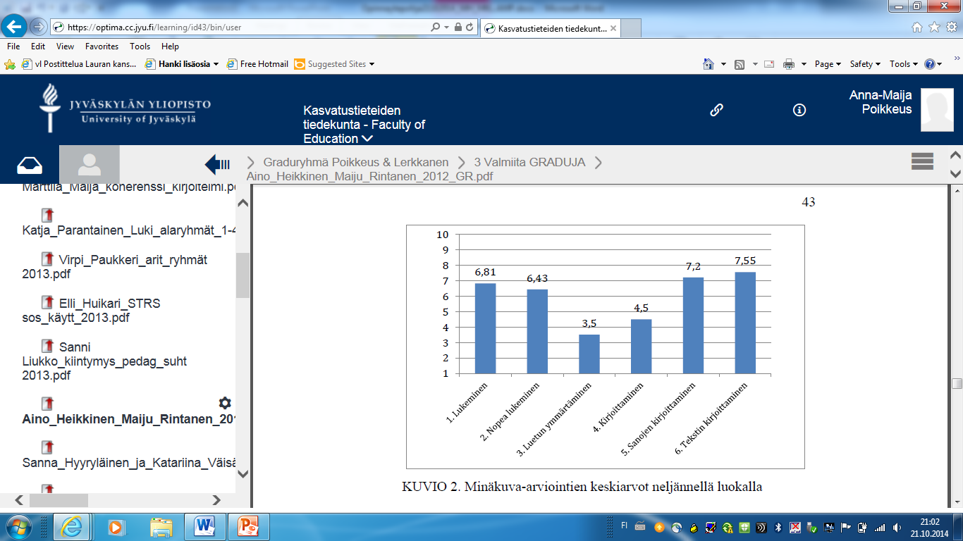

FIGURE 2. The Mean Values of Self-Image Assessments in Year Four of Primary School

Text text…. Text text text text (Figure 4). Text text text text. Text text text text. Text text text text. Text text text text. Text text text text. Text text text text. Text text text text

## Answering Research Problem 2 (heading according to content)

The second research question or problem is usually answered in the second subsection of the Results section. Note that the indicators can be constructed in different ways in qualitative research. Text text text text (see Figure 3). Text text text text. Text text text text. Text text tekstiä text. Text text text text.

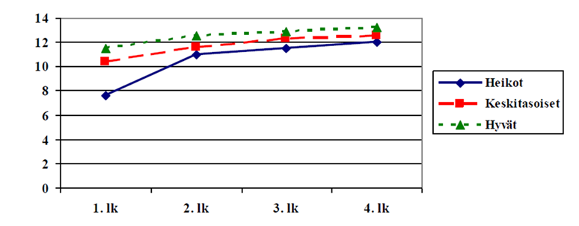

FIGURE 3. Development of Number Sequence Skills in Weak, Average and Good Readers

Text text text (see Figure 4). Text text text.

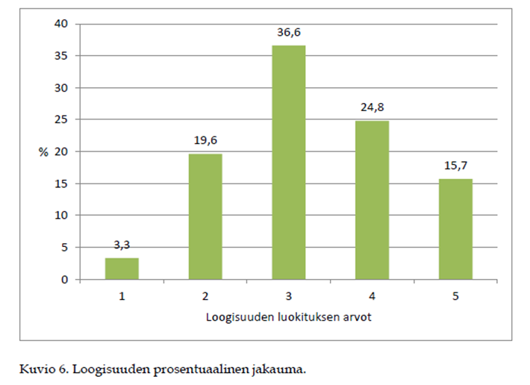

FIGURE 4. The distribution percentage for logic in essays

Text text text.

# DISCUSSION

The Discussion section can be divided into subsections or structured with headings at the beginning of lines. Examples of headings:

* Examination of results
* Reliability of the study
* Generalisability and limitations
* Applicability of research results (not compulsory)
* Challenges for further research

REFERENCES

Journal articles with doi:

Bush, T. (2012). International perspectives on leadership development: making a difference. *Professional Development in Education 38*, 663-678.doi:10.1080/19415257.2012.660701

Gentry, W. A., Eckert, R. H., Munusamy, V. P., Stawiski, S. A., & Martin, J. L. (2014). The needs of participants in Leadership development programs: A qualitative and quantitative cross-country investigation. *Journal of Leadership & Organizational Studies*, *21*, 83-101. doi: 10.1177/1548051813483832

If each issue of a journal begins on page 1, give also the issue number:

Ang, L. (2012). Leading and managing in the Early Years: A study of the impact of a NCSL programme on children’s centre leaders’ perceptions of leadership and practice. *Educational Management Administration & Leadership 40*(3), 289-304.doi: 10.1177/1741143212436960

Aubrey, C., Godfrey, R., & Harris. A. (2013). How do they manage? An investigation of early childhood leadership. *Educational Management Administration & Leadership* *41*(1), 5-29.doi: 10.1177/1741143212462702

Journal article without doi:

Waniganayake, M. (2014). Being and becoming Early Childhood leaders: Reflections on leadership studies in Early Childhood education and the future leadership research agenda. *Journal of Early Childhood Education Research, 3*(1), 65-81. Retrieved from <http://jecer.org/fi/issues/jecer-31-2014/>

* include the issue number and the URL if the reference was retrieved online

A book:

Spillane, J. P. (2006). *Distributed leadership*. San Francisco: Jossey –Bass.

Yukl, G. (2002). *Leadership in organizations*. London: Prentice Hall.

Article in a book:

Huse, Y. (2013). Professional training for beginning directors of Early childhood education programs in Taiwan. In E. Hujala, M. Waniganayake & J. Rodd (Eds.) (pp. 113-125). *Researching Leadership in Early Childhood Education*. Tampere: Tampere University Press.

Offermann L. R., & Scuderi N. F. (2007). Sharing leadership: who, what, when and why. In B. Shamir, P. Pillai, M. C. Bligh, & M. Uhl-Bien (Eds.) (pp. 51–91). *Follower-centered perspectives on leadership. A tribute to the memory of James R Meindl*. Greenwich: Information Age Publishing.

A dissertation (and an example of a non-English reference)

Nivala, V. (1999). *Päiväkodin johtajuus*. [Leadership in educare] (Unpublished doctoral dissertation). University of Lappland.

An internet based source

If a source is available only from internet database, add: Retrieved from Name of database and/or web address.

Appendices

Appendix 1 Practical layout instructions

*Lining****:*** 1,5

*Font****:*** Book Antiqua

*Font size****:***

Cover page**:**

Title of the thesis 16 (align text center)

Name of the student 14 (align text center)

Other text 12 (align text right)

Headings (bolding):

**ABSTARCT, CONTENT, REFERENCES** and **APPENDICIES** (CAPITAL LETTERS) 14

**HEADINGS OF THE MAIN CHAPTERS**

(CAPITAL LETTERS) 16

**Second-Level Heading 14**

**Third-Level Heading 12**

Text 12

Figures and tables 10,5

*Marginal****:***

top 2,5 cm, bottom 2,5 cm, left 3 cm, right 3 cm

*Direct citations****:***

below two lines, inside the text separated with ”quotation marks” or in italics without quotation marks

longer indentions: indention 1 cm, lining 1, no quotation marks and no italics

Appendix 2 Instructions for Adding Page Numbers

The following guidelines help you set page numbering in Word:

Go to the first page of your Introduction section and select Page Layout (Sivun asettelu) from the top menu. In Page Setup (Sivun asetukset) you find the Breaks (Vaihdot) menu. Select the right option from Section Breaks (Osanvaihdot). You can enter the header by clicking the top of the page. The first page on which it says Header -Section 2- (Ylätunniste –osa 2-) in blue provides the option Same as Previous (Sama kuin edellinen) in blue. This option disappears when you click the icon Design – Link to Previous (Rakenne – linkitä edelliseen) in the top menu.